Appendix B

# Backups

Full backup using mysqldump:

Then I tried to create an event that would execute the command and create full backups weekly but it failed because you cannot use OS commands inside events, so I’m giving up.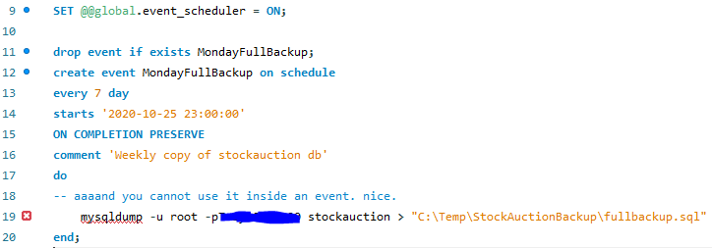

# Data Export

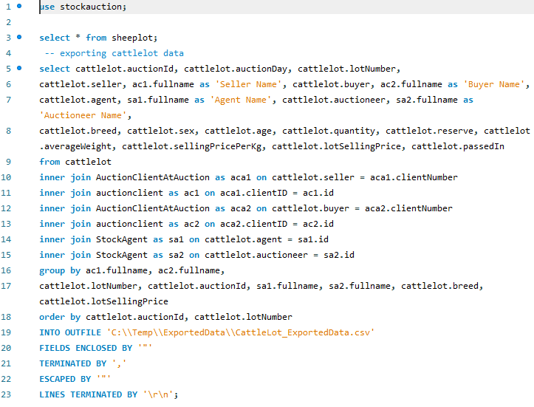

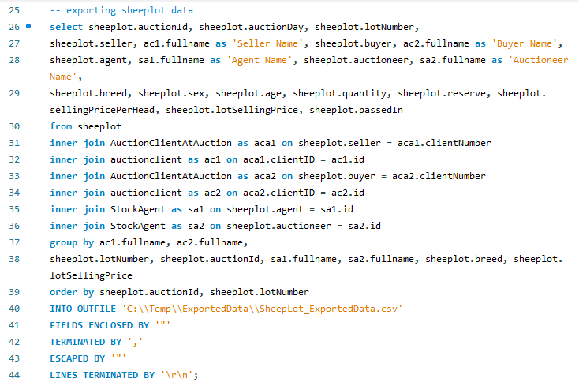

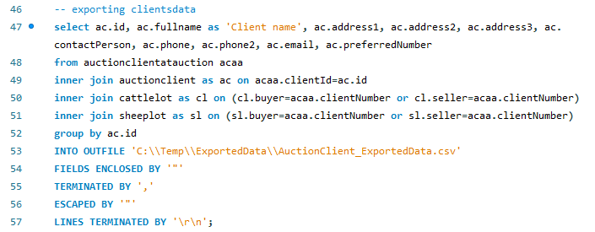

The output files can be found in a corresponding folder attached with the submission.

# Users and Rights

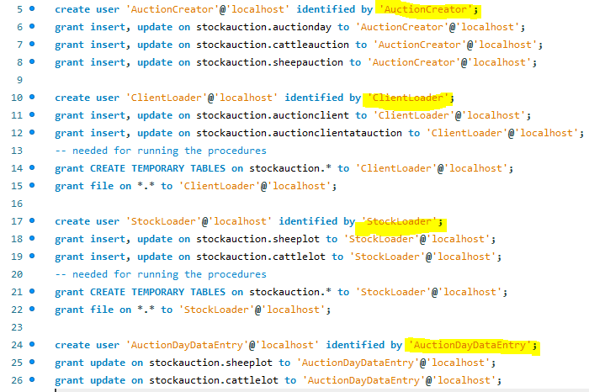

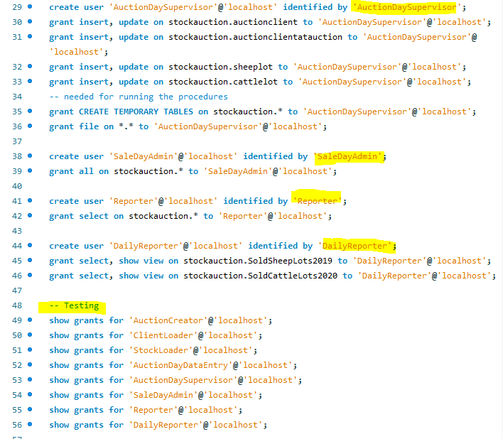

# Roles

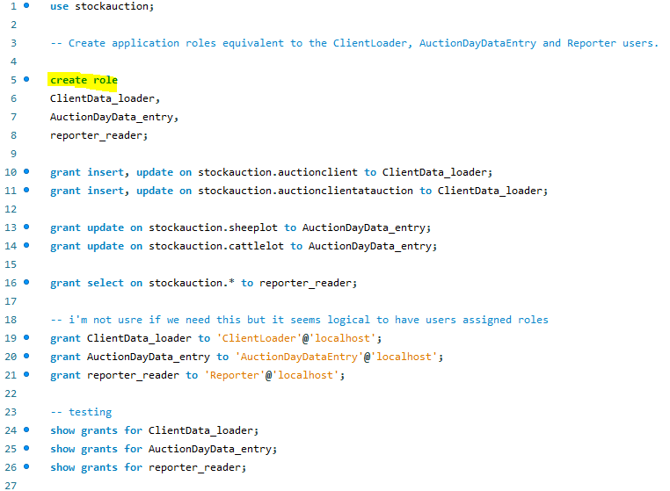

# SP Rights

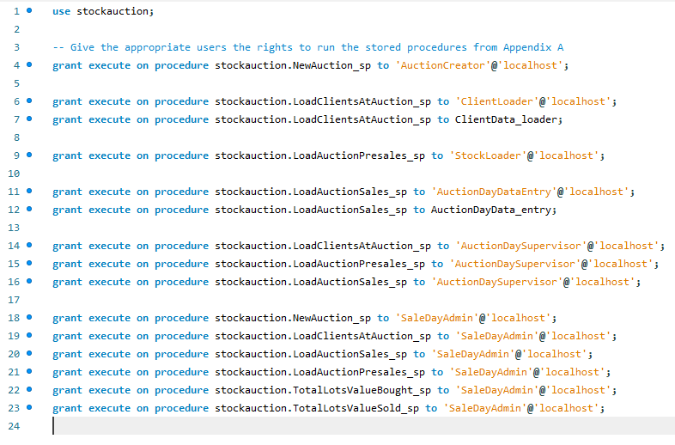

# Backup User

# 